ALiSS Flash Search Component Documentation

Introduction 2
Installation 2
Required Files 2
Optional Files 3
Uploading 3
Embedding 4
1. Include the required Javascript files in your webpages 4
2. Create a DIV to contain the FSC in your web page: 4
3. Use the functionality of the SWFObject library to embed the FSC in your page. 4
Embedding via SWFObject example: 5
4. Activate the dynamic resizing of the FSC 5
Configuring 6
About the Configuration File 6
Configuration File Properties 6
Example Configuration File 7
Styling 10
Color Values 10
Unique Classes 10
Specification Syntax 11
Data Type Specification 11
CSS Class Definitions 12
Application Class 12
RectBorder Class 13
Button Class 15
BusyGradient Class 16
List Class 17
RelatedResultView Class 18
SearchBox Class 19
RelatedItemPreview Class 20
RelateditemPreview_PreviewImage Class 21
RelatedItemPreview_Progress Class 22
Message Class 23
Troubleshooting FAQ 25
FSC does not appear on the page 25
Styles do not render correctly 25
Click to activate? 25
Example Styles 26

Introduction

The ALiSS Flash Search Component (FSC) is designed to allow your organization to quickly deploy an interactive search interface to the powerful ALiSS Term-Indexing (what do we call the backend?) WebService.

The FSC is developed in Adobe Flash 8, configured via an external XML file, and styled via an external CSS file. This flexible structure will allow you to match the visual look and feel of the FSC to your organizations visual identity.

The FSC was developed for the EEA in 2006 by TietoEnator Government Services A/S.

Installation

Some text about installation of backend service….

Required Files

- flashclient.swf
This is the FSC interface itself. It will be embedded inyour page templates.
- flash_config_xml
This is a UTF-8 XML file, that contains configuration information for the flash client. This file handles text localization, defines URLs for necessary web services, and provides categorization information for search results.
This file can be arbitrarily named, but the path to the file must be supplied to FSC at runtime.
- flash_client.css
This is a CSS file that defines the visual look and feel of the component. While flash supports many standard CSS classes and properties, there are some exceptions, and unique properties that are explained in the “Styling” section.
This file can be arbitrarily named, but the path to the file must be supplied to FSC at runtime via the XML configuration file.
- swfobject.js
This javascript file allows you to easily embed the FSC for display in IE and FireFox/Mozilla. See “Embedding” for detailed usage examples.

Optional Files
- BrowserLayoutManager.js
This file allows the embedded flashclient.swf to dynamically resize itself on the webpage. If you make use of this file, the FSC can be embedded at a height of 22px, and will dynamically expand its’ DIV to show search results, contracting back to minimum height when no results are displayed. Combining this functionality with a high Z-Level allows your FSC to “pop-down” and display content above the body content off your page.
If this file is not used, the FSC must reserve a large vertical area to display results, which is not generally desirable.

Uploading
Upload the required files to your webserver or CMS system. General practice suggests a file structure such as:

ProjectRoot/
ALiSS/
flashclient.swf
js/
BrowserLayoutManager.js
swfobject.js
css/
flash_client.css
xml/
flash_config_xml

Embedding
To embed the FSC in your page template, you need to :

1. Include the required Javascript files in your webpages
<script type="text/javascript" src="js/swfobject.js"></script>

<script type="text/javascript" src="js/BrowserLayoutManager.js"></script>

2. Create a DIV to contain the FSC in your web page:

<DIV id=”smartsearchcontainer” style=”z-index:4”> You can put the HTML-Forms alternative to the flash client here. If flash is not supported you page will display this content.</DIV>

3. Use the functionality of the SWFObject library to embed the FSC in your page.

The following script block should be placed at the end of your HTML content, so that it executes when the page is finished rendering. This is required since the script targets a DIV by ID, so the DIV must be present in the DOM before the script executes.
Due to changes in IE, flash movies should be embedded with the SWFObject javascript library. If this library is not used, IE will not display the flash files. See the URL in this footnote to read an explanation of why this is necessary.

Embedding via SWFObject example:

<script>
// <![CDATA[

var fo = new SWFObject("flashclient.swf", "The_ID_OF_THE_FSC_FLASH_OBJECT", "100%", "100%", "8", "#FFFFFF");

fo.addVariable("variable1", "urlOfTheXMLConfigFile");
fo.addParam("quality", "medium");
fo.addParam("wmode", "transparent");
fo.addParam("salign", "RT");
fo.addParam("scale", "noscale");
fo.addParam("allowscriptaccess", "always");
fo.addParam("AllowScriptAccess", "always");

fo.write("The_ID_of_The_DIV_Which_Contains_The_FSC");

// ]]>
</script>

4. Activate the dynamic resizing of the FSC
In order for the FSC to be able to expand and contract so that it can display information to the user, you must add the following javascript calls to your page template. This script should run after the SWFObject script in step 3.
<script>
// <![CDATA[

/*====================================
* The following code sets up the correct containers
* and flash controls for the
* BrowserLayoutManager controller.
* This is the only required script for usage.
*/

browserLayoutManager_registerFlashContainerForLayout("The_ID_of_The_DIV_Which_Contains_The_FSC");

browserLayoutManager_registerFlashObjectForLayout("The_ID_OF_THE_FSC_FLASH_OBJECT ");

browserLayoutManager_addListener(window,"resize",browserLayoutManager_Resize,false);

// ]]>
</script>

Configuring

About the Configuration File

The flash_config_xml file handles all of the configuration for text localization, labels, webservice urls, etc. Each configuration element is written as an “item” node, identified by the “paramid” attribute. For example, the XML defines where the FCS can locate the external CSS file like this:

<item paramid="css_path">misc_/ALiSS/flash_client.css</item>

Configuration File Properties

Below each element is explained:

css_path
The relative URL to the CSS file

service_url
The relative or absolute URL to the Webservice interface

search_prefix_url
Since URL requests to Google searches place the search term in the middle of the URL, we divide the google URL into prefix and suffix. See the example configuration file for more detail.

search_suffix_url
See Above

result_pages_size
The number of results to return (10=set of 10 result items)

search_fail_button_txt
Text to display on button if no results are found. The button forwards the user to a Google search (as defined in search_prefix_url and search_suffix_url) on the failed terms.

no_suggestions_txt
Text to display when no Term Suggestions are available.

no_definition_txt

on_search_txt
Text to display while waiting for search results

see_more_def_txt
Button label text that appears below the Definition. (ex: “See more…”)

see_more_res_txt
Same functionality as see_more_def_txt but this button is placed below the search results, and appears even if no Definition is supplied.

enable_suggest_icons
Valid values are true and false. If true, the FSC displays icons to the left of result items. Icons are defined in the “group” tags.

enable_preview_images
Valid values are true and false. If true, the FSC will load a preview image when the user hovers the mouse over a result item.

enable_related_results
Valid values are true and false. If true, when the user selects a Term, a second search is made against the WebService and a Definition and Related Results are displayed. The user can then navigate to a specific result or the Concept Page for a specific Term.

definition_max_length
Number, Defines the maximum number of characters in a definition. If the Definition is > than this number, trailing ellipses “…” are added at the end of the limit.

preview_show_delay
Number of milliseconds (1000 = 1second) to wait before loading a preview image.

group
The Group tags define the categories, or “groups”, that results from the service fall into. This allows the FSC to assign each group a unique suggestion icon. See enable_suggest_icons. These tags are usually dynamically generated. (ANTONIO?)

Example Configuration File

﻿<?xml version="1.0" encoding="UTF-8"?>

<flashconfig>
<item paramid="service_url">http://webservices.eea.europa.eu/alissBIG/agentBIG</item>
<item paramid="search_prefix_url">http://google.eea.europa.eu/search?q=</item>
<item paramid="search_suffix_url">&amp;client=default_frontend&amp;site=default_collection&amp;ie=UTF-8&amp;oe=UTF-8&amp;output=xml_no_dtd&amp;proxystylesheet=default_frontend</item>
<item paramid="result_pages_size">10</item>
<item paramid="search_fail_button_txt">Search on all EEA websites</item>

<item paramid="no_suggestions_txt">Suggestions not available for this term. Try the search below.</item>
<item paramid="no_definition_txt">There is currently no definition available.</item>

<item paramid="on_search_txt">Smart searching ...</item>
<item paramid="see_more_def_txt">See more ...</item>
<item paramid="see_more_res_txt">All results ...</item>
<item paramid="on_search_txt">Smart searching ...</item>
<item paramid="enable_suggest_icons">false</item>
<item paramid="enable_preview_images">true</item>
<item paramid="enable_related_results">true</item>
<item paramid="definition_max_length">200</item>
<item paramid="preview_show_delay">500</item>
<item paramid="preview_click_to_visit_txt">Click to visit page</item>
<item paramid="preview_click_to_visit_txt">Click to visit page</item>
<item paramid="css_path">misc_/ALiSS/flash_client.css</item>

<item paramid="group">
<id>9223504369</id>
<name>Data sets</name>
<standardicon>misc_/ALiSS/standardicon.gif</standardicon>
</item>

<item paramid="group">
<id>8813732861</id>
<name>Indicators</name>
<standardicon>misc_/ALiSS/standardicon.gif</standardicon>
</item>

<item paramid="group">
<id>3199784604</id>
<name>Reports</name>
<standardicon>misc_/ALiSS/standardicon.gif</standardicon>
</item>

<item paramid="group">
<id>0420268561</id>
<name>EUROPA Environment</name>
<standardicon>/misc_/ALiSS/standardicon.gif</standardicon>
</item>

<item paramid="group">
<id>6654084361</id>
<name>JRC</name>
<standardicon>/misc_/ALiSS/standardicon.gif</standardicon>
</item>

<item paramid="group">
<id>0475788842</id>
<name>Maps and graphs</name>
<standardicon>/misc_/ALiSS/standardicon.gif</standardicon>
</item>
</flashconfig>

Styling
The external CSS file that handles the visual appearance of the FSC is in a standard CSS format. However, there are a few properties, attributes and syntax that should be explained.

Color Values
Hexadecimal color values are usually written #RRGGBB. In the CSS file, you should only write hex color values in this format: 0xRRGGBB.

Unique Classes
There are CSS Classes unique to the FSC. They are:
- RectBorder
- Button
- TextInput
- List
- RelatedResultsView
- SearchBox
- RelatedItemPreview
- RelatedItemPreview_PreviewImage
- RelatedItemPreview_Progress
- Message
- RelatedResultItem

CSS Specification

Specification Syntax

ClassName{
propertyName:[value1 | value2];
propertyName:Number;
propertyName:Boolean;
propertyName:Normalised;
propertyName:0xRRGGBB;
optionalPropertyName:[value1 | value2];

}

Where [value1 | value2] indicates the property must be either value1 or value2. The default value is in bold, meaning that value1 is the default if no value is set via CSS. Optional properties are in bold italics.

Data Type Specification
Number
A property type of Number means any integer or float can be specified.
Example:
propertyName:256;

Normalised
A property type of Normalised means any value between 0 and 1 may be specified.
Example:
propertyName:.5;

Boolean
A property type of Boolean means you may specify either “true” or “false” without the quotations.
Example:
propertyName:true;

Milliseconds
A unit of time. 1000 msec= 1second.
Example:
propertyName:1000;

CSS Class Definitions

Application Class
The Application class controls top level styles for the FSC. In this release, the only properties defined are those which control the appearance of the DropShadow underneath the Term Suggestions and Related Result list. The DropShadow for the RelatedItemPreview is defined separately, in the RelatedItemPreview Class.

Application{
dropShadowDistance: Number;
dropShadowAngle: Number;
dropShadowColor: 0xRRGGBB;
dropShadowAlpha: Normalised;
dropShadowBlurX: Number;
dropShadowBlurY: Number;
dropShadowStrength: Number;
dropShadowQuality: Number;
dropShadowInner: Boolean;
dropShadowKnockout: Boolean;
dropShadowHideObject: Boolean;

minimizedWidth: Number;
minimizedHeight: [ auto | Number ];
expandedWidth: Number;
expandedHeight: [ auto | Number ];

userTimeoutDuration: Milliseconds;
}

Since this is a custom class, there is no extended information about this class at Adobe.com.

RectBorder Class

The RectBorder Class control the drawing of borders for any component which has its’ borderStyle property set to any “rounded” style value. These values are “rounded,roundedTop,roundedBottom,roundedLeft,roundedRight”.

When you set a component to a rounded style, you can override the values set in the RectBorder class.

If you wanted a “roundedTop” border on a List component, you might write the List class like this:

List{
borderStyle:roundedTop;
borderRadius:20;
}

The CSS properties listed in blue are the extended functionality of the RectBorder class. In order to make use of them, the borderStyle must be set to one of the “rounded” properties. The properties in black are standard, and only used for drawing Flash-standard 3d/beveled borders.

﻿RectBorder{

borderCapColor:0xRRGGBB;
borderColor: 0xRRGGBB;
buttonColor: 0xRRGGBB;
highlightColor: 0xRRGGBB;
shadowCapColor: 0xRRGGBB;
shadowColor: 0xRRGGBB;
themeColor: 0xRRGGBB;

borderStyle:[none | solid | rounded | roundedTop | roundedBottom | roundedLeft | roundedRight];

borderRadius: Number;
borderOffset: Number;

borderGradientType:[ linear | radial ];
borderGradientColor:[ 0xRRGGBB, 0xRRGGBB];
borderGradientColorRatio:[ Number, Number ];
borderGradientAngle: Number;
borderGradientAlpha: Number;

borderStrokeColor: 0xRRGGBB;
borderStrokeThickness: Number;
borderStrokeAlpha: Number;
borderStrokeStyle:[ none | round | square ];

}

Classes that support RectBorder properties:
- List
- TextArea
- SearchBox
- RelatedResultsView
- RelatedItemPreview
- RelatedItemPreview_PreviewImage
- Message

For extended information about this class, see Adobe documentation.
To see the sourcecode that supports the extended properties, view the com.eea.styling.skins.RoundRectBorder class in the Actionscript source directory.

Button Class

The Button Class controls all style for Button controls in the FSC. Due to the limitations of the Button component, you cannot alter the base grey color of the button. You can control the color shading on rollover, press, and release, as well as border colors. Text style and size are supported as well.

Button{
themeColor: 0xRRGGBB;
backgroundColor: 0xRRGGBB;
color: 0xRRGGBB;

font-size:Number;
font-weight:[ none | bold];
font-style:[ normal | italic];
font-family:Verdana,_sans;

}

For extended information about this class, see Adobe documentation.

BusyGradient Class

The BusyGradient Class defines the style for the windows-style BusyGradient that appears while the FSC is waiting for a response from the server.

The properties color1 and color2 define the two colors that make up the gradient, busyHeight defines the height of the BusyGradient, and padding defines the spacing between the SeachBox and the BusyGradient.

Note: When setting the Application.minimizedHeight, make sure the value is equal or greater to the SearchBox height + BusyGradient.busyHeight + BusyGradient.padding. If the Application is sized smaller than this, the BusyGradient may not be visible.

BusyGradient{
color1: 0xRRGGBB;
color2: 0xRRGGBB;
busyHeight: Number;
padding: Number;
}

List Class

The List Class controls all styling for List objects. This includes the list of “Suggested Terms”, and the “Related Items” list. Setting properties here will affect both of these controls. However, while the List Class completely controls the display of the “Suggested Terms”, the RelatedResultView Class has a number of unique properties.

List{

backgroundColor: 0xRRGGBB;

borderStyle:[none | solid | rounded | roundedTop | roundedBottom | roundedLeft | roundedRight];

color: 0xRRGGBB;
font-family:Verdana;
font-weight:[normal | bold];

rollOverColor: 0xRRGGBB;
selectionColor: 0xRRGGBB;
textRollOverColor: 0xRRGGBB;

}

For extended information about this class, see Adobe documentation.

RelatedResultView Class

The RelatedResultsView Class is one of the most complex class in the FSC. It controls styling for the scrollable list of related results, and the Term Definition.

The only complexity in this class is the alternatingRowColors and rowColor1, rowColor2 properties. These properties let you set alternating rows of color in the related results list. The alternatingRowColors property will over-ride any values set via rowColor1 and rowColor2. You can use either alternatingRowColors or the rowColor1,rowColor2 properties.

The rowHeight property control the height of each item in the related result list. The default is 80 pixels. Setting it higher will add padding above and below each item, setting it lower will result in clipping and undesirable results.

RelatedResultsView{
backgroundColor: 0xRRGGBB;

alternatingRowColors:[ 0xRRGGBB, 0xRRGGBB];
rowColor1: 0xRRGGBB;
rowColor2: 0xRRGGBB;

previewDefaultHeight: Number;

borderStyle:[none | solid | rounded | roundedTop | roundedBottom | roundedLeft | roundedRight];

borderRadius: Number;
borderOffset: Number;

borderGradientType:[linear | radial];
borderGradientColor:[ 0xRRGGBB, 0xRRGGBB];
borderGradientColorRatio:[ Number, Number];
borderGradientAngle: Number;
borderGradientAlpha: Number;

rowHeight: Number;
}

Since this is a custom class, there is no extended information about this class at Adobe.com.

SearchBox Class

The SearchBox Class control the styling of the TextInput where the user enters search terms.

SearchBox {
align:[left | center | right];
widthMax: Number;
backgroundColor: 0xRRGGBB;
color: 0xRRGGBB;
font-weight:[none | bold];
borderStyle:[none | solid | rounded | roundedTop | roundedBottom | roundedLeft | roundedRight];

}

Since the SearchBox class inherits from the generic TextInput class, you can use any TextInput styles. To see an list of these styles, view the Adobe documentation.

RelatedItemPreview Class

The RelatedItemPreview Class controls the styling for the popup that appears when the user hovers the mouse over a RelatedResultItem.

In order to easily support the preview image popping above or below the RelatedResultItem, a few properties are dynamically altered. The dropShadowAngle is inverted when the popup appears above the RelatedResultItem. This allows the popup to blend in with the color of the RelatedResultItem by not drawing a drop shadow over the join between them. If you wish to disable the dropShadow, simply set the dropShadowAlpha, dropShadowDistance, dropShadowBlurX and dropShadowBlurY to 0.

Note: To make the blend between the Preview and the list item perfect, set the RelatedItemPreview.backgroundColor and List.rollOverColor to the same color value.

RelatedItemPreview{

borderStyle:[none | solid | rounded | roundedTop | roundedBottom | roundedLeft | roundedRight];

borderRadius: Number;
borderOffset: Number;
borderGradientType:[linear | radial];
backgroundColor: 0xRRGGBB;

dropShadowDistance: Number;
dropShadowAngle: Number;
dropShadowColor: 0xRRGGBB;
dropShadowAlpha: Normalised;
dropShadowBlurX: Number;
dropShadowBlurY: Number;
dropShadowStrength: Number;
dropShadowQuality: Number;
dropShadowInner: Boolean;
dropShadowKnockout: Boolean;
dropShadowHideObject: Boolean;
}
Since this is a custom class, there is no extended information about this class at Adobe.com.

RelateditemPreview_PreviewImage Class
This class controls the styling of the RelatedItemPreview content. Specifically, it controls the color, padding and borderstyle to use around the loaded preview image.

RelatedItemPreview_PreviewImage{
borderStyle:[none | solid | rounded | roundedTop | roundedBottom | roundedLeft | roundedRight];
borderRadius: Number;
borderOffset: Number;
borderGradientType:[linear | radial];
backgroundColor: 0xRRGGBB;
}

Since this is a custom class, there is no extended information about this class at Adobe.com.

RelatedItemPreview_Progress Class

When a preview image is loading, the RelatedItemPreview displays the progress percentage in the Preview popup. This class determines the formatting of that text.

RelatedItemPreview_Progress{
font-family:Verdana,_sans;
font-size:22;
font-weight:bold;
color:0x333333;
}

As this class inherits from TextField, it supports the CSS properties defined in the Adobe documentation.

Message Class

The Message class controls the styling and appearance of the control which displays the “No results…” message. (See the “no_suggestions_txt” item in the XML configuration file.)

Message{
borderStyle:[none | solid | rounded | roundedTop | roundedBottom | roundedLeft | roundedRight]; borderRadius:Number;
borderOffset: Number;

borderGradientType:[linear | radial];
borderGradientColor:[0xRRGGBB, 0xRRGGBB];
borderGradientColorRatio:[ Number, Number];
borderGradientAngle: Number;
borderGradientAlpha: Number;

font-family:Verdana,_sans;
font-size: Number;
font-weight:[normal | bold];
color: 0xRRGGBB;
}

Since this is a custom class, there is no extended information about this class at Adobe.com.
RelatedResultitem Class

The RelatedResultItem Class controls the styling and display of items shown in the Related Result list.

Note: The emphasisColor property is used to generate the display HTML of the result item text. As such, it requires you to specify the hexadecimal color in standard HTML #RRGGBB format. Using 0xRRGGBB will cause the control to not highlight the emphasized text.

The highlighting is applied to text within an HTMl tag of “<b>” defined by the “snippet” property which is part of the WebService result set.

RelatedResultItem{
font-family:Verdana,_sans;
color: 0xRRGGBB;
emphasisColor:#RRGGBB;
}

Troubleshooting FAQ

FSC does not appear on the page

- Have you correctly embedded the “flashclient.swf”?
If you have, you should be able to right click on the div contating the FSC and see the Flash Player context menu. (“About Flash, etc)
- Are you passing the URL of the XML Configuration file to the embedded flashclient.swf?
See: “Embedding via SWFObject example”
The URL can be relative or absolute. If the URL is on another server, or within another domain, make sure the server has a crossdomain.xml file that allows access by the Flash Player. If not, you will be presented with a security dialog. Details in the following footnote.
- Is the URL of the CSS file correct?
If the “css_url” item in the XML Config file is incorrect, the FSC will not load. Make sure it is a correct relative or absolute URL, and if the file is supplied from another domain see the information about crossdomain.xml in footnote 6.

Styles do not render correctly
If no styling appears, or styling that does not match expectations, check point #3 above and make sure that the URL for the CSS file is correctly entered in the XML Config file.

Click to activate?
If Internet Explorer™ asks you to “click to activate this control”, than you have not used the SWFObject embedding that is required by IE as of April 11th 2006. See the section of this document entitled “Embedding via SWFObject example” for instruction on embedding the FSC.

Example Styles

Minimal

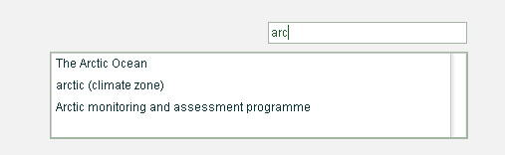
Continues on following pages…

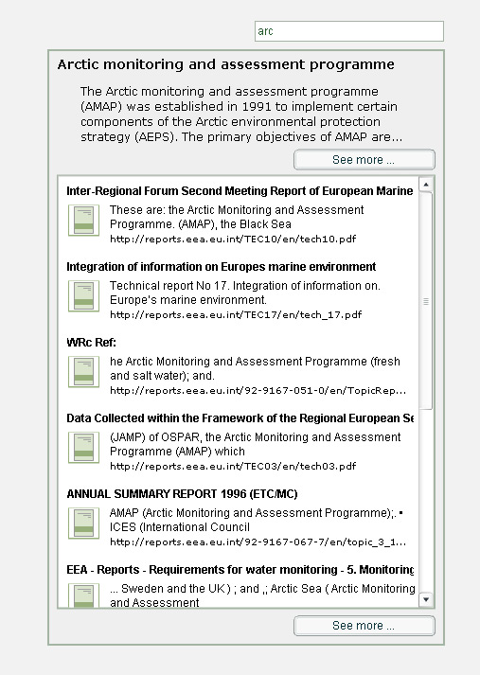

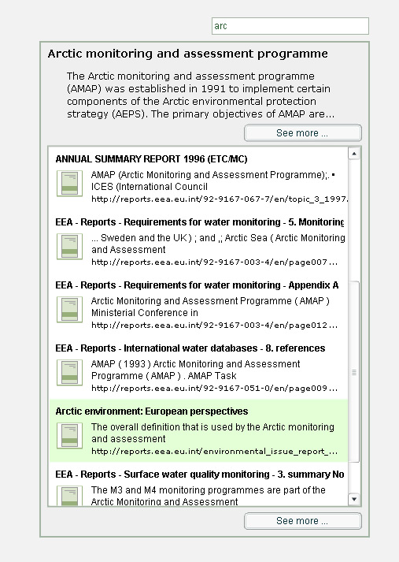

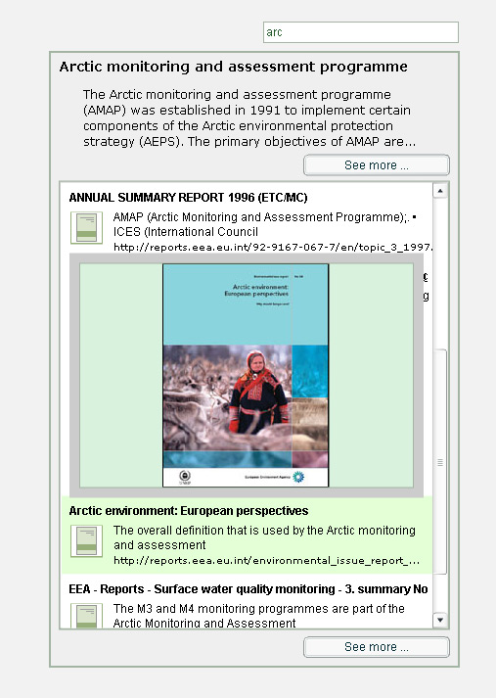

EEA Style


Continues on following pages…

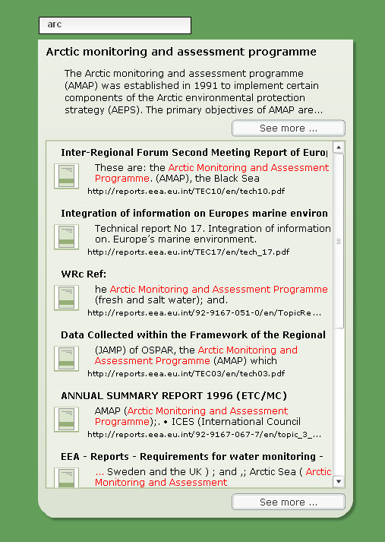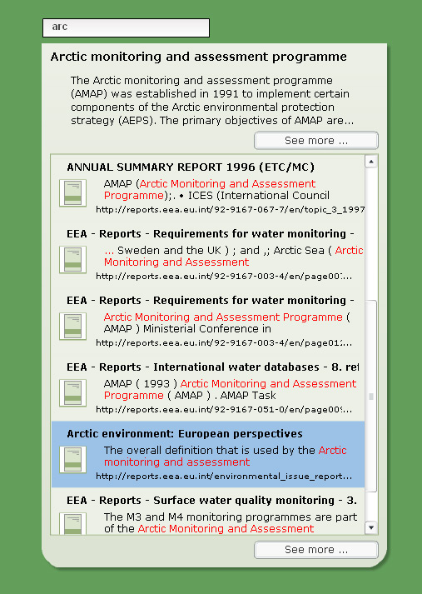

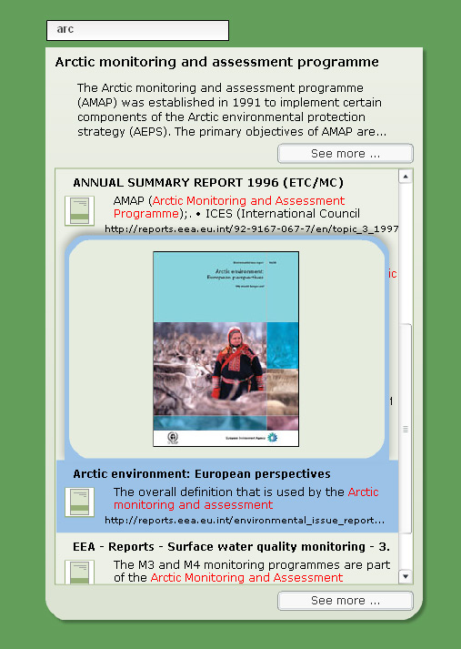

http://makeashorterlink.com/?Y4F42134D
http://makeashorterlink.com/?O2B71524D
http://makeashorterlink.com/?R5A81524D
http://makeashorterlink.com/?X5292324D
http://makeashorterlink.com/?H23A3624D
http://makeashorterlink.com/?F2FB5224D
http://www.adobe.com/cfusion/knowledgebase/index.cfm?id=tn_14213

